Hands on 1:
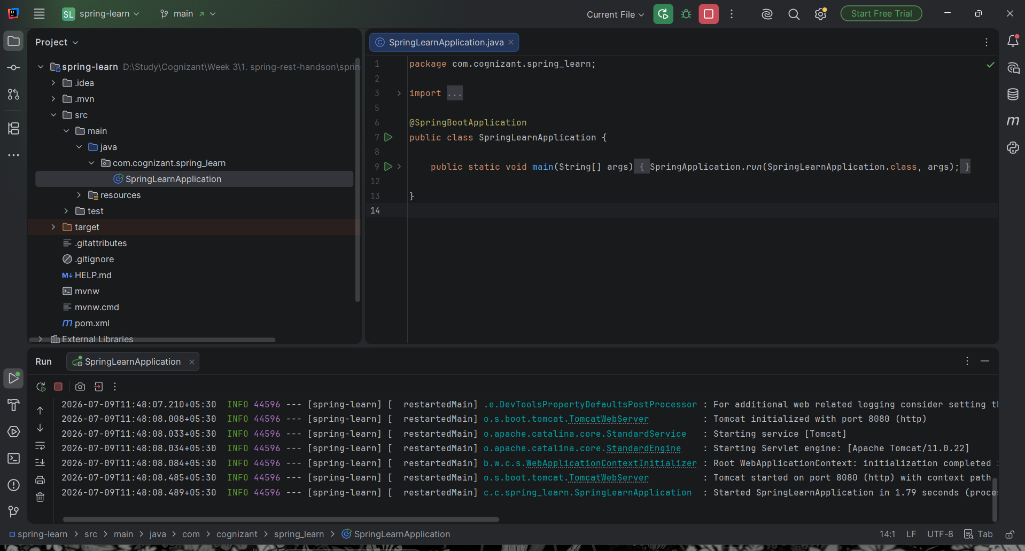

SpringLearnApplication.java
package com.cognizant.spring_learn;
import org.springframework.boot.SpringApplication;
import org.springframework.boot.autoconfigure.SpringBootApplication;
@SpringBootApplication
public class SpringLearnApplication {
public static void main(String[] args) {
SpringApplication.run(SpringLearnApplication.class, args);
}
}

pom.xml
<?xml version="1.0" encoding="UTF-8"?>
<project xmlns="http://maven.apache.org/POM/4.0.0" xmlns:xsi="http://www.w3.org/2001/XMLSchema-instance"
xsi:schemaLocation="http://maven.apache.org/POM/4.0.0 https://maven.apache.org/xsd/maven-4.0.0.xsd">
<modelVersion>4.0.0</modelVersion>
<parent>
<groupId>org.springframework.boot</groupId>
<artifactId>spring-boot-starter-parent</artifactId>
<version>4.1.0</version>
<relativePath/> <!-- lookup parent from repository -->
</parent>
<groupId>com.cognizant</groupId>
<artifactId>spring-learn</artifactId>
<version>0.0.1-SNAPSHOT</version>
<name/>
<description/>
<url/>
<licenses>
<license/>
</licenses>
<developers>
<developer/>
</developers>
<scm>
<connection/>
<developerConnection/>
<tag/>
<url/>
</scm>
<properties>
<java.version>17</java.version>
</properties>
<dependencies>
<dependency>
<groupId>org.springframework.boot</groupId>
<artifactId>spring-boot-starter-webmvc</artifactId>
</dependency>
<dependency>
<groupId>org.springframework.boot</groupId>
<artifactId>spring-boot-devtools</artifactId>
<scope>runtime</scope>
<optional>true</optional>
</dependency>
<dependency>
<groupId>org.springframework.boot</groupId>
<artifactId>spring-boot-starter-webmvc-test</artifactId>
<scope>test</scope>
</dependency>
</dependencies>
<build>
<plugins>
<plugin>
<groupId>org.springframework.boot</groupId>
<artifactId>spring-boot-maven-plugin</artifactId>
</plugin>
</plugins>
</build>
</project>

Hands on 4:
SpringLearnApplication.java
package com.cognizant.springlearn;
import org.springframework.boot.SpringApplication;
import org.springframework.boot.autoconfigure.SpringBootApplication;
import org.springframework.context.ApplicationContext;
import org.springframework.context.support.ClassPathXmlApplicationContext;
@SpringBootApplication
public class SpringLearnApplication {
public static void main(String[] args) {
SpringApplication.run(SpringLearnApplication.class, args);
displayCountry();
}
public static void displayCountry() {
ApplicationContext context =
new ClassPathXmlApplicationContext("country.xml");
Country country =
context.getBean("country", Country.class);
System.out.println(country);
}
}
Country.java
package com.cognizant.springlearn;
public class Country {
private String code;
private String name;
public Country() {
}
public String getCode() {
return code;
}
public void setCode(String code) {
this.code = code;
}
public String getName() {
return name;
}
public void setName(String name) {
this.name = name;
}
@Override
public String toString() {
return "Country{" +
"code='" + code + '\'' +
", name='" + name + '\'' +
'}';
}
}
pom.xml
<?xml version="1.0" encoding="UTF-8"?>
<project xmlns="http://maven.apache.org/POM/4.0.0" xmlns:xsi="http://www.w3.org/2001/XMLSchema-instance"
xsi:schemaLocation="http://maven.apache.org/POM/4.0.0 https://maven.apache.org/xsd/maven-4.0.0.xsd">
<modelVersion>4.0.0</modelVersion>
<parent>
<groupId>org.springframework.boot</groupId>
<artifactId>spring-boot-starter-parent</artifactId>
<version>4.1.0</version>
<relativePath/> <!-- lookup parent from repository -->
</parent>
<groupId>com.cognizant</groupId>
<artifactId>spring-learn</artifactId>
<version>0.0.1-SNAPSHOT</version>
<name/>
<description/>
<url/>
<licenses>
<license/>
</licenses>
<developers>
<developer/>
</developers>
<scm>
<connection/>
<developerConnection/>
<tag/>
<url/>
</scm>
<properties>
<java.version>17</java.version>
</properties>
<dependencies>
<dependency>
<groupId>org.springframework.boot</groupId>
<artifactId>spring-boot-starter-webmvc</artifactId>
</dependency>
<dependency>
<groupId>org.springframework.boot</groupId>
<artifactId>spring-boot-devtools</artifactId>
<scope>runtime</scope>
<optional>true</optional>
</dependency>
<dependency>
<groupId>org.springframework.boot</groupId>
<artifactId>spring-boot-starter-webmvc-test</artifactId>
<scope>test</scope>
</dependency>
</dependencies>
<build>
<plugins>
<plugin>
<groupId>org.springframework.boot</groupId>
<artifactId>spring-boot-maven-plugin</artifactId>
</plugin>
</plugins>
</build>
</project>

country .xml
<?xml version="1.0" encoding="UTF-8"?>
<beans xmlns="http://www.springframework.org/schema/beans"
xmlns:xsi="http://www.w3.org/2001/XMLSchema-instance"
xsi:schemaLocation="
http://www.springframework.org/schema/beans
https://www.springframework.org/schema/beans/spring-beans.xsd">
<bean id="country"
class="com.cognizant.springlearn.Country">
<property name="code" value="IN"/>
<property name="name" value="India"/>
</bean>
</beans>

